Student Online Registration System
Shantavius L. Johnson
CST 499 Capstone for Computer Software Technology
Professor Amr Elochouemi
April 3, 2023

Software Requirements Specification
for
Student Online Registration System
Shantavius L. Johnson
University Of Arizona Global Campus
April 3, 2023
Table of Contents
Table of Contents ii
Revision History ii
1. Introduction 1
1.1 Purpose 1
1.2 Document Conventions 1
1.3 Intended Audience and Reading Suggestions 1
1.4 Product Scope 2
1.5 References 2
2. Overall Description 2
2.1 Product Perspective 2
2.2 Product Functions 3
2.3 User Classes and Characteristics 5
2.4 Operating Environment 5
2.5 Design and Implementation Constraints 6
3. External Interface Requirements 6
3.1 User Interfaces 6
3.2 Hardware Interfaces 7
3.3 Software Interfaces 7
4. System Features 7
4.1 System Feature 1 7
4.2 System Feature 2 7
4.3 System Feature 3 8
5. Other Nonfunctional Requirements 8
5.1 Performance Requirements 8
5.2 Safety Requirements 8
5.3 Security Requirements 8
5.4 Software Quality Attributes 8
6. References………………………………………………………………………………………9

Revision History
Name | Date | Reason For Changes | Version

Introduction

Purpose
This Software Requirements Specification (SRS) document aims to outline the specifications for a web-based system for registering for courses. New users will be able to sign up for the system, set up an account and profile, and register for the three semesters of courses given each year. The method must be simple to use, safe, and effective.

Document Conventions
This is an SRS document entitled Student Online Registration System. This document has no version or revision number. An opening, an overall description, functional and non-functional requirements, an external interface, system features, other non-functional requirements, and a glossary are all included in the structure of this SRS document. To make it easier for readers to navigate the material provided, the document has a clear table of contents as well as headings and subheadings.

Intended Audience and Reading Suggestions
The intended audience for The University of Arizona Global Campus Course Registration System would primarily be students of an educational institution who need to register for courses. Also, the system would be used by the university's administrative staff and faculty members who need to manage course registrations and enrollments. In general, the Online Course Registration System would be created to meet the requirements of different parties involved in a learning environment, particularly students and the administrative staff in charge of handling course registrations and enrollments.

Product Scope
Users may register for the system, make an account, and a profile using the online course registration system. Utilize their unique ID and passcode to log in to the system. Check out the courses that are available each term. Enroll in classes, subject to space being available and registration limits. Cancel the course registration if a session is complete. Students can add their names to a waiting list. View their enrollment status and course plan. Check out their profile information and make any required updates.

References
Sinanaj. (2019), Writing a Software Requirements Specification Document. Writing a software requirements specification document | by Eni Sinanaj | Medium

Overall Description

Product Perspective
Students will use this new self-contained software, which is a standalone web application, to sign up for classes online. In order to acquire information about course availability and schedules, the system will interface with the university's current student information system. The student will engage with the web-based interface used by the online registration system. A database that will keep sensitive data like the user profile and student name, number, place of residence, e-mail address, and more.

Product Functions
The data flow diagram depicts the information flow between these processes and the parties concerned. For instance, information moves from the process of registering a new user to the process of creating a user profile and from the process of logging in to the process of listing courses. The Waiting List and Course, Capacity Management processes also receive data from the Enroll in Course and Cancel Enrollment processes. The diagram gives a high-level overview of the system's primary operations, and data flows overall (Geeks for Geeks, 2023 ).
Once the Web application is Executed:
- Registration (registration will prompt you to either login or register a new user).
- New User
- Log In
- New User
- Create a Profile
- Enroll in a course.
- Add to a waiting list.
- Logging In
- View available course listings.
- Cancel a course.
- View the course capacity.
- Enroll in a course.
  - Cancel the Course
      - View course capacity.
  - View the waiting list.
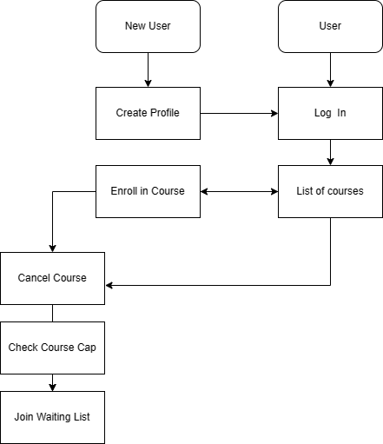
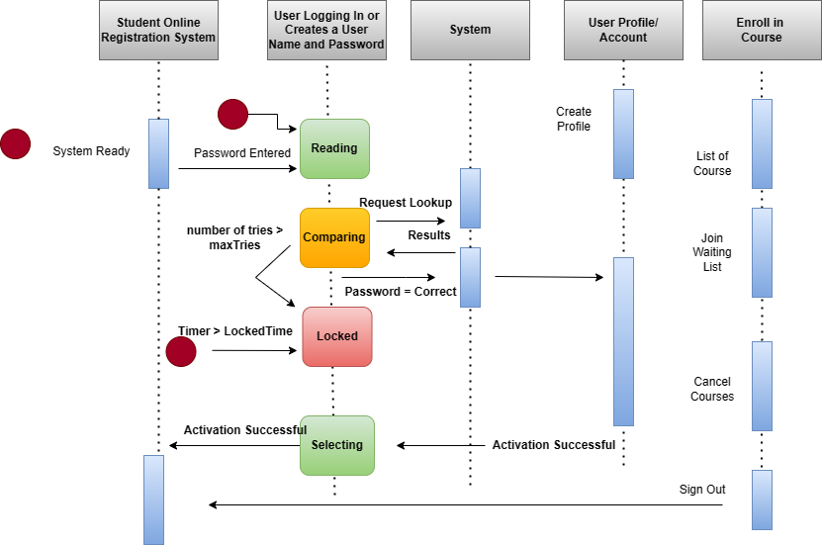

User Classes and Characteristics
The Students: These will be the heavy user of the system. They will use the system to register for courses, access their grades, pay for fees, cancel course, and join waiting list.

Faculty and Staff: These individual will have an administrative access level to the system to manage the students record, enter grades, and sent oot announcements along with other forms of communications.

Operating Environment
The operating environment for this system will be in the convenience of the student's home, where the program will be run on hardware such a laptop, desktop computer, tablet, or mobile device. The software will offer a means of getting to the online registration platform. The database that stores sensitive information will have extensive security measures, and the user will have access to it while utilizing the system in the comfort of their home.

Design and Implementation Constraints
- Security: To stop illegal access to student data, the system should be built with a high level of security.
- Interface that is easy to use: Users should have no trouble navigating the system and should receive clear instructions from it.
- Data management: The system must be able to accurately and effectively store, handle, and retrieve student data.
- The system should have the ability to integrate with other systems, including student information systems, financial aid systems, and course administration systems.

External Interface Requirements

User Interfaces
User interface: The system ought to feature an intuitive user interface that makes it simple for students to sign up for classes, examine their schedules, and send money.

Accessibility: Users with disabilities, especially those who use assistive technologies like screen readers, should be able to utilize the system.

System compatibility should include support for the various hardware, software, and web browsers that students frequently utilize.

Hardware Interfaces
Hardware for the server: The system should be hosted on a server with sufficient processing power to handle the volume of users and requests anticipated. Also, the server needs to have enough storage space for student data.

Hardware for the network: The system should be linked to a solid network infrastructure that offers users high-speed connectivity.

Web server: The system should be operated on a web server that can handle the relevant scripting languages and software components.

System Features

System Feature 1
Process of registering: Students should be able to register for classes online, including choosing courses, creating schedules, and paying fees.

System Feature 2
Course administration capabilities, such as scheduling classes, keeping track of grades, and interacting with students, should be provided by the system for teachers and administrators.

System Feature 3
Management of student information: The system should store and manage student data, including financial, academic, and personal information.

Other Non-functional Requirements

Performance Requirements
Performance: The system should be able to support numerous concurrent users without noticeably degrading its efficiency.

Security Requirements
Security: The system must be protected against unauthorized access, hacking, and other security lapses. Adequate safeguards must also be in place to safeguard student data.

Software Quality Attributes
Interoperability: To offer a smooth user experience, the system should be able to integrate with other systems, such as learning management systems, student information systems, and finance systems.

References

Sinanaj. (2019), Writing a Software Requirements Specification Document. Writing a software requirements specification document | by Eni Sinanaj | Medium
Geeks for Geeks (2023). What is Data Flow Diagram. What is DFD(Data Flow Diagram)? - GeeksforGeeks

